5. Frontend/Interface (Industry-Level Detail)
The Frontend/Interface provides a secure, intuitive web-based dashboard for clinicians to interact with the AI-Assisted Diagnostic Reporting Support system. It enables upload of anonymised images, real-time visualization of AI highlights (heatmaps/attention maps), side-by-side viewing, and structured editing/approval of draft reports. The design prioritizes usability, accessibility (WCAG 2.1 AA compliance), and strict human-in-the-loop enforcement to align with UK clinical governance and MHRA human factors guidance.
Implementation resides in /frontend/ – recommended framework: Streamlit (for rapid prototyping and ease of deployment in secure environments) or Flask/FastAPI + React (for more customizable, production-grade UI). Integration with backend via secure API calls.
Key Features and Layout
- Upload Section: Secure file upload (DICOM/NIfTI) with validation and progress feedback.
- Image Viewer: Interactive DICOM viewer (using libraries like Cornerstone.js or OHIF viewer integration) with zoom, pan, windowing.
- AI Highlights Overlay: Toggleable heatmap/attention map from ViT analysis.
- Report Editor: Structured sections (Technique, Findings, Impression) with AI draft pre-filled, syntax highlighting, and mandatory "AI-Assisted" watermark.
- Approval Workflow: Edit → Review changes → Explicit "Approve & Sign" button (logs clinician ID/timestamp).
- Additional: Audit log view, session timeout, role-based access.
Industry-Level Example Screenshots and Demo Visuals
Figure 36: Clinician dashboard with side-by-side original image, heatmap overlay, and structured report editor (High-fidelity example of integrated AI radiology interface.)

journals.sagepub.com
U“AI” Testing: User Interface and Usability Testing of a Chest X ...
Suggested filename: fig36-side-by-side-heatmap-report-editor.pdf
Figure 37: AI-assisted chest X-ray reporting interface with attention map and draft findings

pubs.rsna.org
Automation Bias in Mammography: The Impact of Artificial ...
Suggested filename: fig37-chestxray-ai-interface.pdf
Figure 38: Multimodal AI dashboard showing image viewer, heatmap, and editable report sections

ejrai.com
From image to report: Fully AI-generated radiology reports using ...
Suggested filename: fig38-multimodal-report-dashboard.pdf
Figure 39: ProstateCancer.ai-style interface with AI highlights and report drafting panel
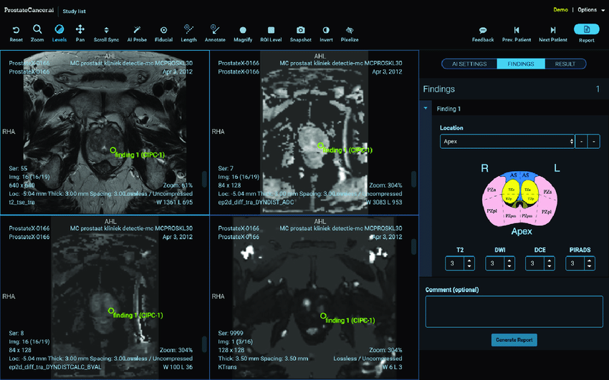
researchgate.net
ProstateCancer.ai user interface. Training and artificial ...
Suggested filename: fig39-prostate-ai-dashboard.pdf
Figure 40: Advanced radiology AI workflow demo with upload, analysis, and approval steps
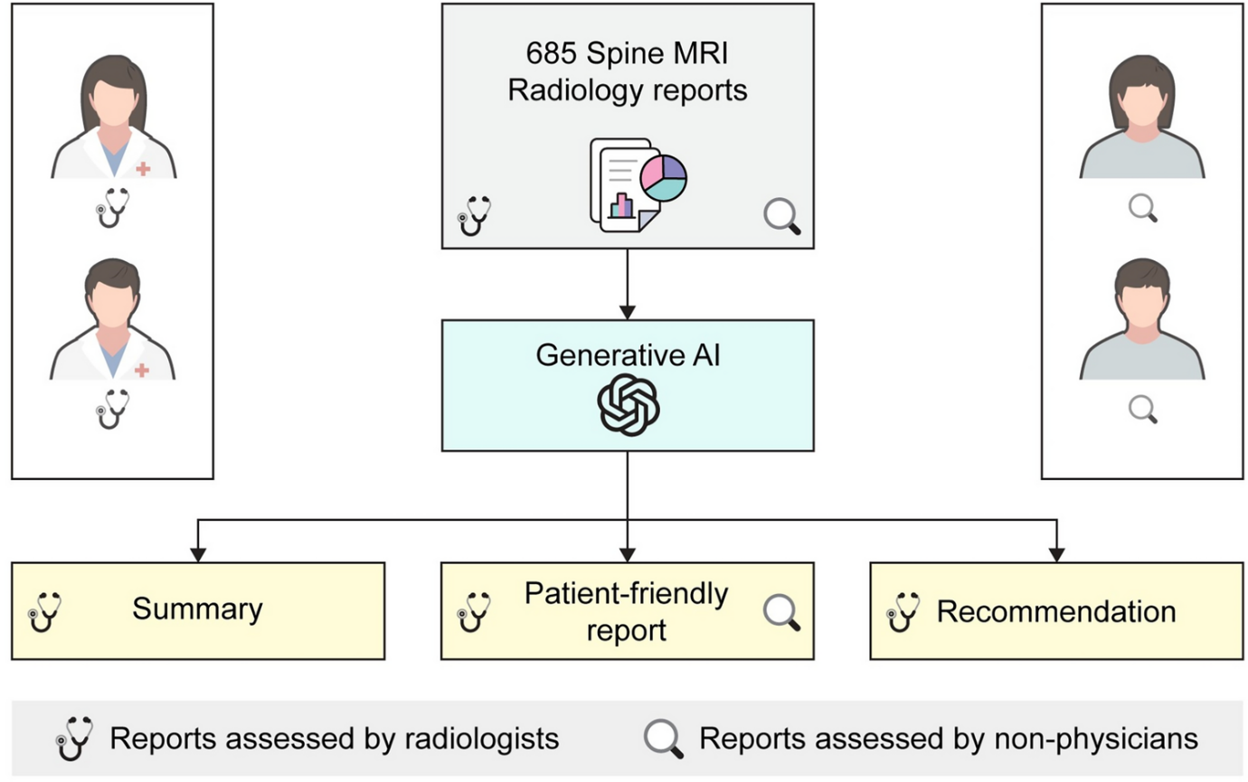
nature.com
Patient-centered radiology reports with generative artificial ...
Suggested filename: fig40-patient-centered-workflow.pdf
Figure 41: Integrated AI reporting tool clinician view with image overlay and structured editing
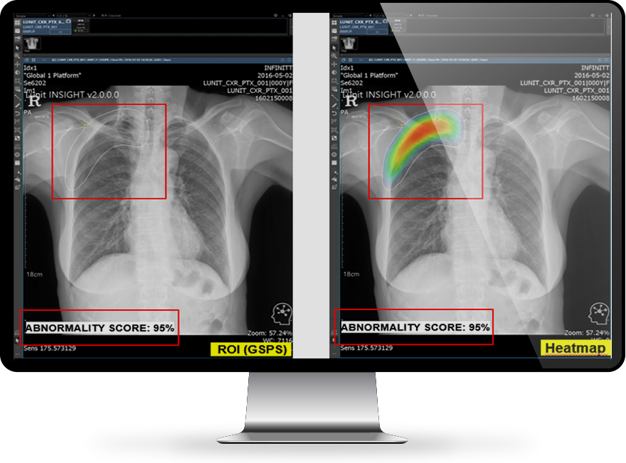
infinittna.com
Advanced Visualization & AI | INFINITT North America
Suggested filename: fig41-integrated-ai-viewer.pdf
Figure 42: Streamlit-based prototype dashboard example (adaptable for medical AI tools)
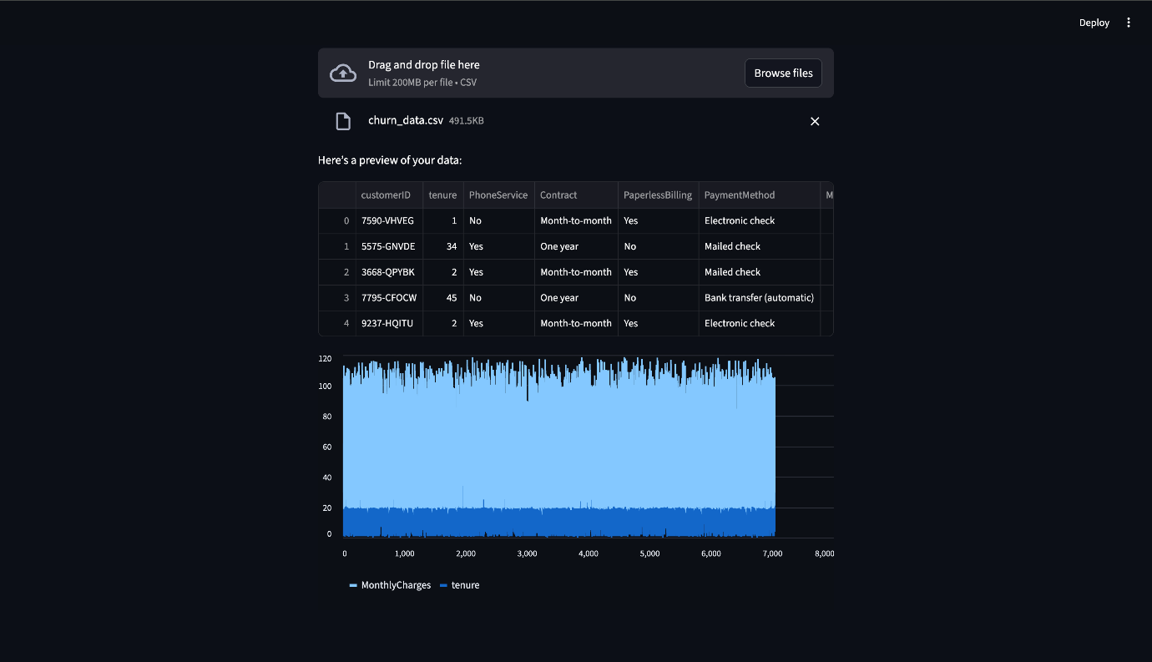
codecademy.com
What is Streamlit? A Complete Guide for Building Data Apps ...
Suggested filename: fig42-streamlit-prototype-ui.pdf
Evidence Artefacts for Repository
- /frontend/app.py (Streamlit) or React components.
- Screenshots folder: /docs/screenshots/ with sequenced images (upload → processing → review → approve).
- Demo video: Short screen recording (e.g., using OBS) uploaded as /docs/demo_workflow.mp4 – showing end-to-end simulation on public data.
This interface ensures seamless integration into clinical workflows, with clear visual cues for AI assistance and mandatory oversight. For assessors, include annotated screenshots explaining user flow and compliance features (e.g., audit trails).

